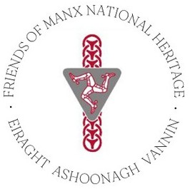

Dear Friends,
Welcome to your December newsletter. As 2025 draws to a close, this month’s edition celebrates all FMNH has supported this year.

Exclusive Member’s Event - Last Chance to Book!
There’s still time to book onto our Exclusive Members’ Event, on Thursday 18th December 2025, 10.30am at the Manx Museum.
'Watch and Ward in the Isle of Man' an illustrated talk by Andy Johnson, Manx National Heritage's Curator of Field Archaeology. Andy will review what was known about watch-keeping (an organised watch-out to sea) and present new evidence for where the watch-sites were located and how the system developed over time.
Image: Cronk ny Merriu.
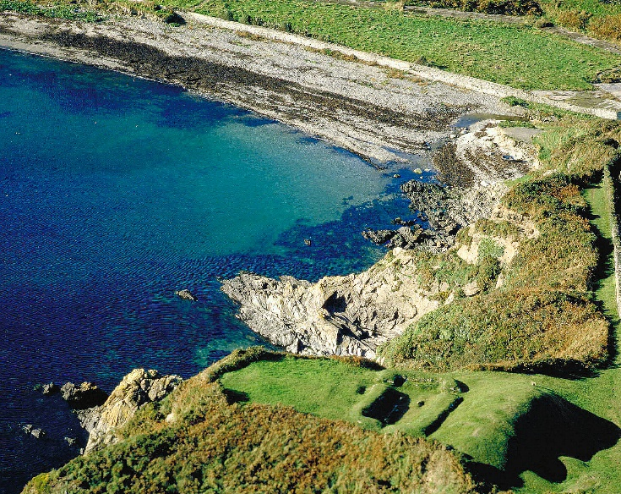
Tickets cost £10 per person, plus optional donation to Friends of Manx National Heritage.
To book, email: info@fmnh.im or call us on 07624 243806.

Museum Projects in Focus
A look at some Manx National Heritage projects, supported by FMNH in 2025:

Conservation Activity
MNH’s Objects Conservator, Chris Weeks, has been working on:

- The Viking silver brooch conserved by Will Murray at the Scottish Conservation Studio, and currently on show in 'National Treasures' at the House of Manannan. The conservation cost £2,450. The work involved cleaning by electrolytic reduction, and stabilisation.

- ‘Yn Arreyder’ by Bryan Kneale, currently being restored at Ramsey Shipping Services Ltd. at a cost of £3,535. The sculpture, on display since 1977 at the bottom of the Manx Museum car park, had become unstable due to rust at the base. The image shows it partly primed, in preparation for painting gloss black.

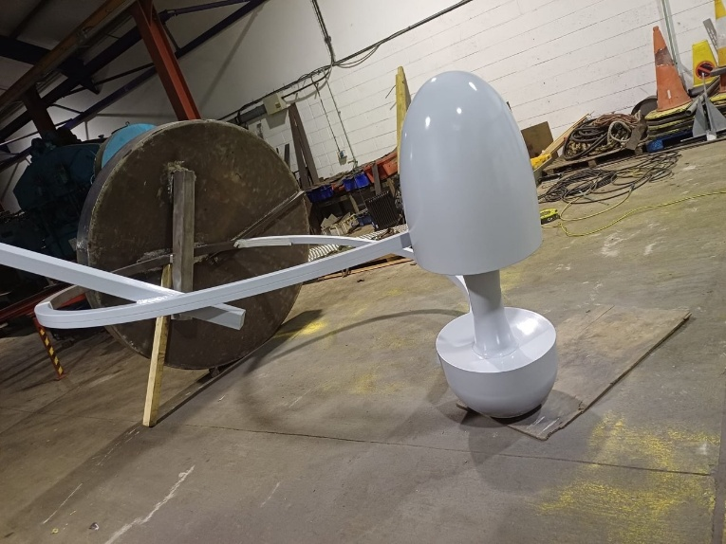

National Treasures Exhibition
This exhibition at the House of Manannan, curated by Allison Fox, showcases the Island's extraordinary collection of treasures, including Viking silver and gold from a thousand years ago, rare four-thousand-year-old Bronze Age jewellery and Manx treasures on loan from the British Museum for the first time. A star of the show is an incredible Viking Age silver brooch from around AD 950, discovered in 2020 by metal detectorist Kath Giles. Found in several pieces, the brooch has been cleaned and conserved with the help of FMNH – and it now looks almost as if it only recently fell from a Viking’s cloak!
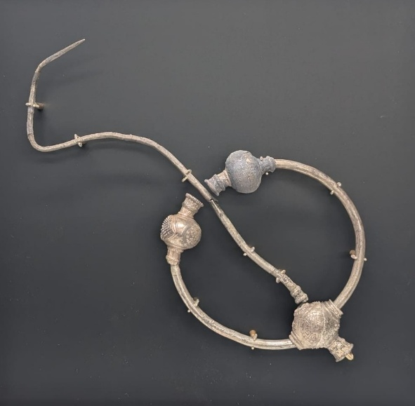
Also on display is a collection of precious metal artefacts on loan from the Trustees of the British Museum. All of the artefacts on loan were found before there was a Manx Museum on the Island, and it is with the assistance of FMNH that local visitors can see the artefacts on their home soil until 1st February.
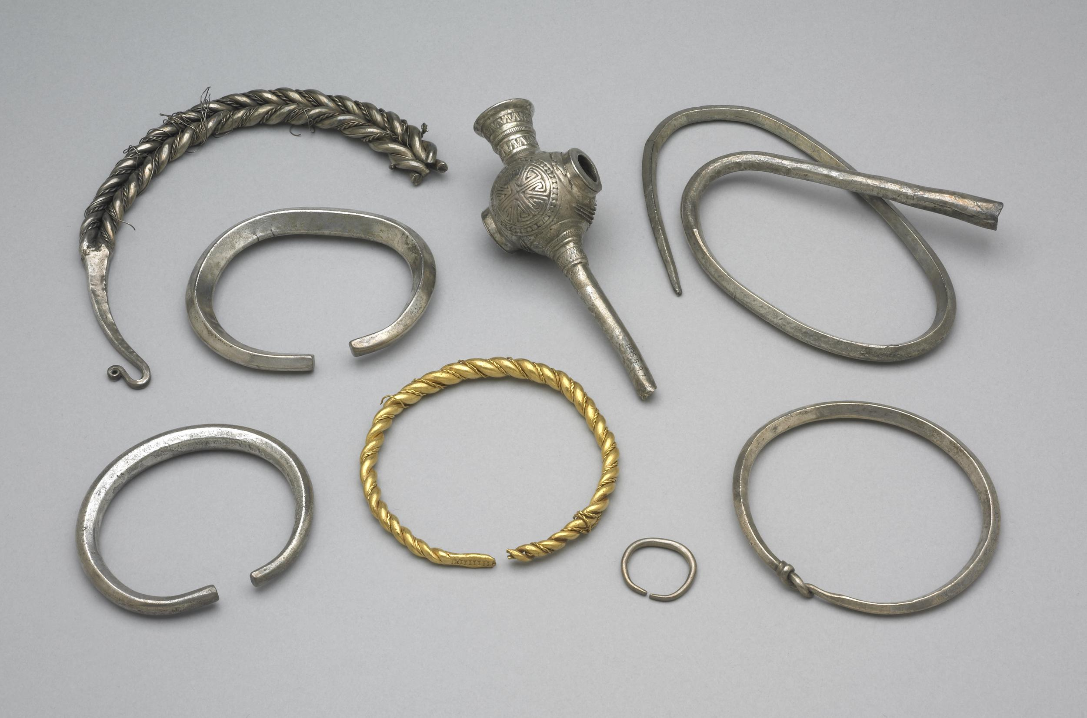

New Entomology Cabinets
With the contribution from FMNH, Manx National Heritage has been able to complete the purchase of new cabinets to improve the storage of the national insect collections, project managed by Laura McCoy, Curator of Natural History. The entomology section, in terms of numbers, is our largest group in the natural history department and contains over 78,000 insect specimens mounted on pins. This collection has built up over many years, with some specimens dating back to the late 1800’s through to material acquired in the last year.
In modern entomology collections, wooden cabinets have been swapped out for ones made with welded, powder coated steel that have a complete seal, which prevents pest infestations and improves environmental buffering. The drawers are still made of wood and have glass tops, but to help reduce damage through handling, insects are grouped together in cardboard trays lined with collections grade inert foam.
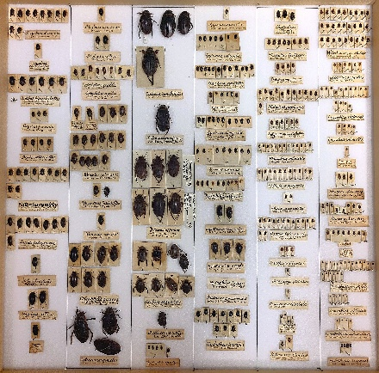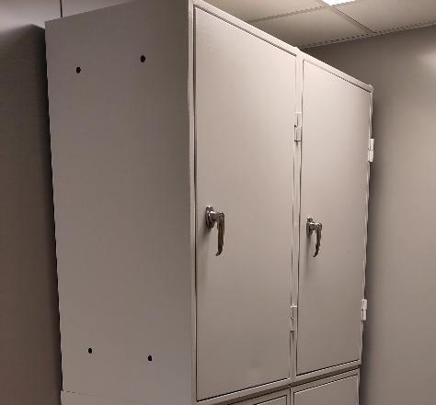

Thanks to Our Members
A big thank you to each one of our members, who have supported Friends of Manx National Heritage once again in 2025. Your support means Friends of Manx National Heritage can assist the wonderful projects above. Your participation ensures Friends of Manx National Heritage can help to conserve the cultural heritage and natural environment of the Isle of Man for future generations; provide funds for the purchase of important works or art and artefacts for the National Collection, land and buildings of national interest for the Nation, and provide volunteers to assist Manx National Heritage staff for projects. Thanks to all involved!

Friends Events for 2026
Hannah Murphy, FMNH’s new Admin and Development Officer, will be putting together our programme of events in the new year; featuring walks, talks and tours. Further information will be in our newsletter.
Are there any events you’d like to see on the programme? Do you know anyone who would like to host a talk or tour for the Friends? We’d love to hear from you. Contact Hannah Murphy: hannah@fmnh.im.

What’s On at Manx National Heritage

There are many wonderful events happening at Manx National Heritage sites over the festive season. Pictured is one of the latest events, Christmas at the Grove. Please see Manx National Heritage’s website for more events and exhibitions: https://manxnationalheritage.im/whats-on/

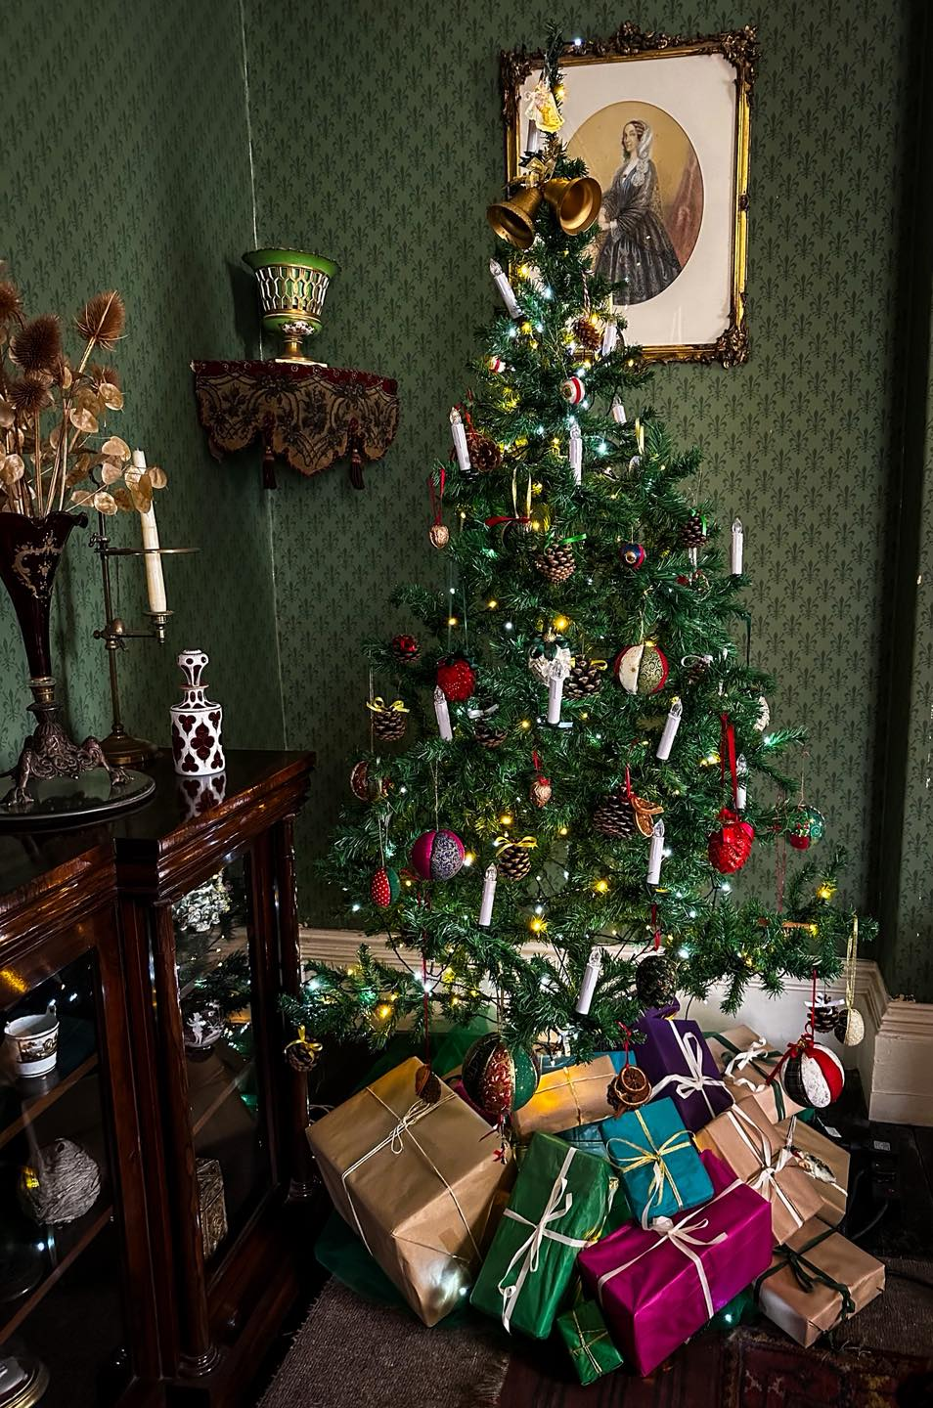
Nollick Ghennal as Blein Vie Noa!
Warmest wishes,
Hannah
Email: hannah@fmnh.im Tel.: 07624 243806
Facebook: https://www.facebook.com/friendsofmnh/ Instagram: friendsofmnh

