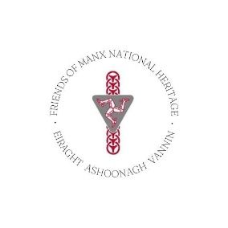

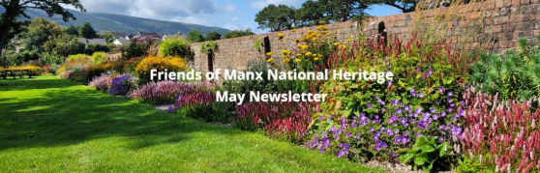

Dear Friends,

Welcome to your FMNH May newsletter. I am delighted to bring you updates and news of FMNH Member exclusive events. As always, you can find a full list of Manx National Heritage sites and their opening times on the [MNH](https://manxnationalheritage.im/visit-2/) website.

**FMNH Member Event – May**

**Thursday 22nd May - Of Monarchs and Man**. Join MNH Archivist Wendy Thirkettle to learn about Royal visits to the island since 1847. An illustrated talk using resources from the library’s collections.

Venue: The Manx Museum. Time: 10.30 Price: £10 per person plus optional donation to FMNH.

**To book:** email [info@fmnh.im](mailto:info@fmnh.im) or call Emma on 07624 243806.

**FMNH Member Event - June**

**Thursday 26th June - Conservation of the Manx National Heritage Collections.** Join MNH Collections Conservation Manager Christopher Weeks in the galleries of the Manx Museum to learn about the amazing conservation of some iconic objects. There is a very limited number of places available on this tour, so please let me know asap if you would like to book.

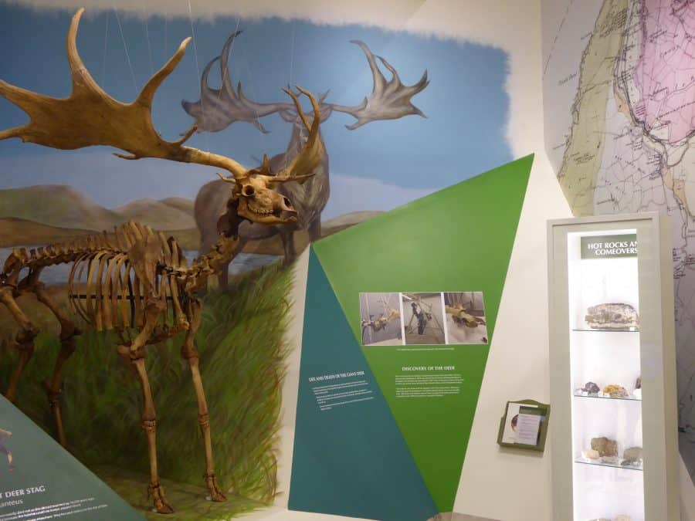

Venue: The Manx Museum. Time: 11.00 Price: £12 per person plus optional donation to FMNH.

**To book:** email [info@fmnh.im](mailto:info@fmnh.im) or call Emma on 07624 243806.

**More Member Events Coming Soon**

**July: Join us for a special guided tour of the beautiful gardens at Rushen Abbey** with Philip Payne, Horticultural Manager for Manx National Heritage. Discover how naturalistic planting enhances the historic setting, learn about the carefully selected plant species, and gain insight into the evolving design of this tranquil space. This is a fantastic opportunity to explore the gardens in their peak season and hear directly from the horticulturist responsible for their care.

**August: The 1961 TT Races.** Honda recently supplied to MNH a documentary made by their own Honda archives. The first part of the talk by MNH Curator Matthew Richardson will introduce the main characters followed by a screening of the full 30-minute documentary.

**September:** **Bride and Jurby Gems.** Illustrated talk by MNH Archivist Wendy Thirkettle using resources from the library’s collections to illuminate these parishes’ fascinating history.

**October:** **Living With the Wire - Internment in the First World War**. Yvonne Cresswell’s talks about internment are always informative and entertaining. Last year we enjoyed learning about Internment in the Second World War. This year we will be travelling back to the Great War.

**November**: **The Isle of Man’s National Treasures with Allison Fox**. Join MNH Curator: Archaeology Allison Fox at the House of Manannan to learn the hidden stories behind some of the Island’s most stunning archaeological artefacts.

**December:** **Watch and Ward on the Isle of Man.** Rescheduled from last year, Andrew Johnson, MNH Curator of Archaeology‘s talk will offerdocumentary and landscape perspectives on a medieval and post-medieval coastal watch system.

Keep an eye out for our newsletters and take a look at our [website](https://www.friendsofmnh.org/events/) for booking information as it is released.

**Knox: Order & Beauty Tour**

In April, over 40 Friends members enjoyed a fascinating and insightful tour of the Knox exhibition with Curator Katie King. I really do recommend that you make a visit to this wonderful exhibition. In fact, you will probably want to go several times, as there is so much to see.

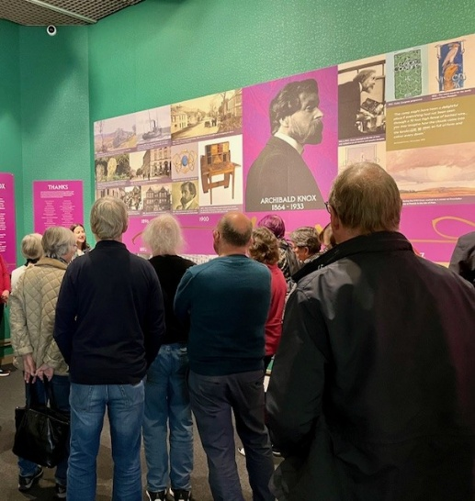

**Reciprocal Agreements and Parking**

Free parking is not included in the reciprocal agreements with our heritage partners such as English Heritage and the National Trust, so please be aware that you may be asked to pay for parking at sites in the UK and beyond when using your Friends card for entry.

**Manx National Heritage Forthcoming Exhibitions and Events**

**Event – Two Day Ukelele Discovery Workshop:** As part of Manx National Heritage’s celebration of the George Formby film ‘No Limit’ they are working with Mannic Ukers at the [Manx Museum](https://manxnationalheritage.im/our-sites/manx-museum/) to provide a fun and educational beginners workshops for George’s legendary musical instrument the Ukulele.

**Date: 30/07/2025 - 01/08/2025 1-3pm Price: £20 per person.** Book on the MNH website <https://manxnationalheritage.im/whats-on/detail/ukulele-discovery-workshop/>

**Exhibition - Leonard McCombe: Through the Lens of War:** Leonard McCombe was one of the Isle of Man’s most successful photographers, producing some of the 20th Century’s most iconic images. To mark the 80th anniversary of VE Day, explore his war photography; many of the images have never been seen before, and all are a testament to the reality of war.

**Date:** **09/05/2025 - 05/10/2025.** **Time: 9.30am - 4.30pm** at the House of Manannan. Free admission – Donations welcome.

**Tour - The Peggy Conservation Facility:** See behind the scenes conservation of Peggy: the world’s oldest schooner.

**Date: Wednesdays and Saturdays. Time: 12pm or 3pm. Price: £12.50, Students £5.50.** Book on the MNH website <https://manxnationalheritage.im/whats-on/detail/behind-the-scenes-at-the-peggy/>

**Tour – Castletown Heritage Sites:** Join MNH on a tour of their Castletown heritage sites including the Old Grammar School, the Old House of Keys and the Nautical Museum.

**Date: Wednesdays and Saturdays. Time: 12pm or 2pm. Price: £16.50, Students £7.50.** Book on the MNH website <https://manxnationalheritage.im/whats-on/detail/coming-soon-castletown-heritage-site-tours/>

**Old House of Keys Sittings:** The Secretary of the House welcomes you to join in the debates on law in this participatory experience. Animated portraits of Keys members and a simulated model of Mr. Speaker bring the debating chamber to life.

**Date: Saturdays. Time: 1.30pm. Price: £12.50, Students £5.50.** Book on the MNH website https://manxnationalheritage.im/shop/product/old-house-of-keys-sittings/

**Manx National Heritage Current Exhibitions**

**Knox: Order & Beauty**

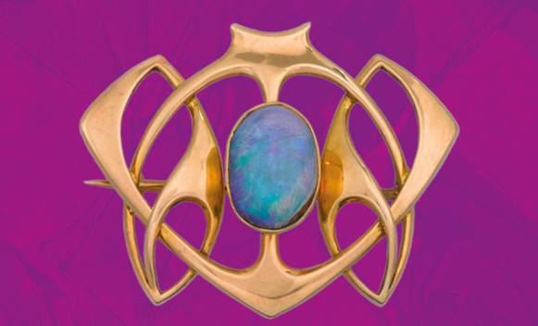

The world’s largest exhibition of works by Archibald Knox is showcased in the National Art Gallery at the Manx Museum. ‘Knox: Order & Beauty’ opened on5th April 2025. There will be a whole host of **special events** to accompany the exhibition, including a series of talks, tours and walks in the footsteps of Archibald Knox – see MNH website for more details: <https://manxnationalheritage.im/whats-on/>

**Date:** **Now until 01/03/2026.** **Time: 9.30am - 4.30pm** at the Manx Museum. Free admission – Donations welcome.

**Gaiety 125**

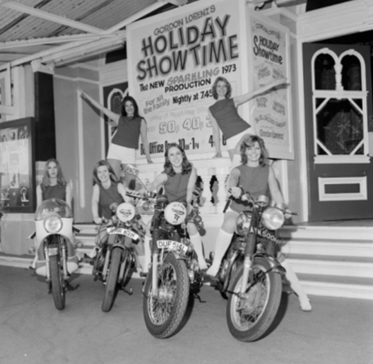

An exhibition celebrating the 125th anniversary of one of the Isle of Man’s most loved buildings, the Frank Matcham designed Gaiety Theatre.

**Date: Now until 18/05/2025.** **Time: 9.30am - 4.30pm** at the Manx Museum. Free admission – Donations welcome.

**‘No Limit’ at 90**



An exhibition marking the 90th anniversary of the release of one of the Isle of Man TT’s best loved tributes. The 1935 film 'No Limit' starred Britain’s top comedian at that time, George Formby, as aspiring TT rider George Shuttleworth.

**Date:** **Now until 07/09/2025.** **Time: 9.30am - 4.30pm** at the Manx Museum. Free admission – Donations welcome.

Please contact Emma [emma@fmnh.im](mailto:emma@fmnh.im) or call me on 07624 243806 if you would like any more information about our events and news. I work part time, but if you leave me a message, I will return your call as soon as I can.

Kind regards,

***Emma***

**Emma Morter**

**Development Officer and Administrator**

Friends of Manx National Heritage

PO Box 55, Douglas,

Isle of Man, IM99 1AE«AddressBlock»

Tel.: 07624 243806

Website: Friends of Manx National Heritage <https://www.friendsofmnh.org/>

Follow our Facebook page:<https://www.facebook.com/friendsofmnh/>

Follow our LinkedIn page: <https://www.linkedin.com/company/friends-of-manx-national-heritage/>

Follow us on Instagram: friendsofmnh

Isle of Man Registered Charity No. 1027