Dear Friends,

Welcome to your FMNH January newsletter. I am delighted to bring you updates and events. As always, you can find a full list of Manx National Heritage sites and their opening times on the [MNH](https://manxnationalheritage.im/visit-2/) website. Although MNH’s seasonal sites are closed for the winter, the Manx Museum and House of Manannan remain open all year and there’s plenty going on in 2025, including a major Archibald Knox exhibition with a series of linked events.

**Manx National Heritage Exhibitions and Events for 2025**

**New for 2025 – Gaiety 125**

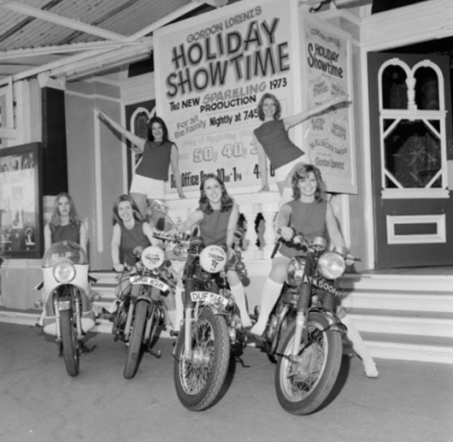

An exhibition celebrating the 125th anniversary of one of the Isle of Man’s most loved buildings, the Frank Matcham designed Gaiety Theatre. **Date: 25/01/2025 -18/05/2025.** 9.30am - 4.30pm at the Manx Museum. Free admission – Donations welcome.

**Event for Children – Mini Musicians – Kingdom of Mann**

* **Join Mini Musicians at the House of Manannan and learn through music and dance about our Island's past.**
* **Date 19/02/2025.Time 10am or 11am; 12 places per session.**
* **Location House of Manannan, Peel.**
* **Price £8 per child (1 accompanying adult free) plus optional donation to MNH.**

**Book here**: <https://manxnationalheritage.im/whats-on/detail/mini-musicians-kingdom-of-mann/>

**New for 2025 – ‘Hear Us’: Sounds of the Sea**

Discover the sounds beneath the surface of the waters surrounding the Isle of Man and gain a new appreciation of the Island’s rich and varied marine life. **14/12/2024 — 30/03/2025** at the Manx Museum. Free admission – Donations welcome.

**New for 2025 – 6 Contemporary Art Exhibition**

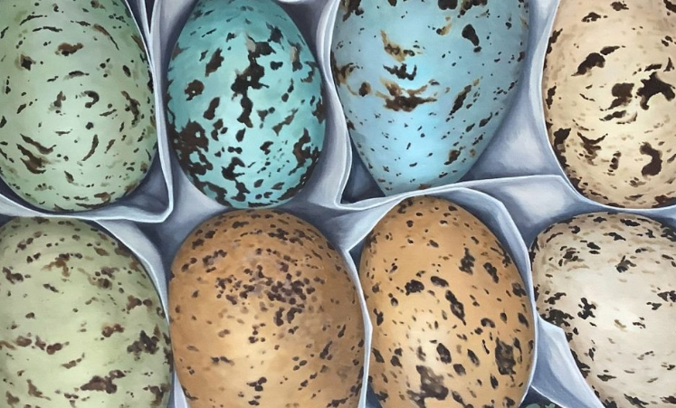

Six contemporary Manx artists: Sally Black, Petrina Kent, Ella Magee, Helen Faragher, Ellie Baker and Ongky Wijana showcase their works on paper, canvas and in stone.

**Date: 15/02/2025 - 27/04/2025.** 9.30am - 4.30pm at the House of Manannan. Free admission – Donations welcome.

**Event – KNOX: Order & Beauty Launch Seminar Day**

To celebrate the launch of KNOX: Order & Beauty, Dr Stephen Martin, Anthony Bernbaum and Paul Carter Robinson will be delivering a series of lectures at the Manx Museum in this unique day seminar. There will be lots of opportunities for questions and answers, with time to explore the exhibition. **05/04/2025** and **06/04/2025,** 11am - 6:30pm. Tickets £20 <https://manxnationalheritage.im/shop/product/knox-order-beauty-launch-seminar-day-5th-april-2025/>

**New for 2025 – Archibald Knox Order & Beauty**

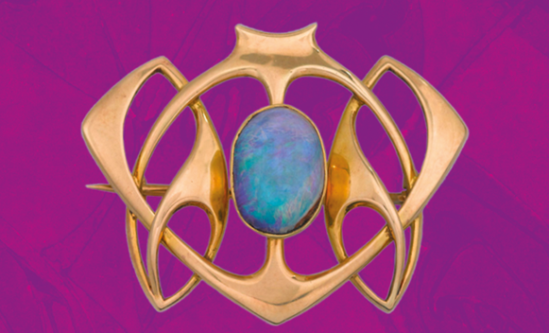

In 2025 the world’s largest exhibition of works by Archibald Knox is set to be showcased in the National Art Gallery at the Manx Museum. ‘Knox: Order & Beauty’ will open on **5th April 2025**. There will also be a whole host of special events to accompany the exhibition, including a series of talks, tours and walks in the footsteps of Archibald Knox – see MNH website for more details: <https://manxnationalheritage.im/whats-on/>

**New for 2025 – ‘No Limit’ at 90**



An exhibition marking the 90th anniversary of the release of one of the Isle of Man TT’s best loved tributes. The 1935 film 'No Limit' starred Britain’s top comedian at that time, George Formby, as aspiring TT rider George Shuttleworth. **Date:** **24/05/2025 - 07/09/2025.** 9.30am - 4.30pm at the Manx Museum. Free admission – Donations welcome.

**Last Chance:** Don’t forget to catch ‘Rare Sightings and Urban Faeries’ by Julia Ashby Smyth at the Manx Museum. Step into the realm of Manx fairy tales, myths and legends in this unique exhibition by artist and illustrator Julia Ashby Smyth. **This exhibition closes on 23rd February.**

**Volunteers**

FMNH are really grateful to all our volunteers for their help. Some of you help out weekly with gardening at MNH sites, some of you help in the Library and Archives, or with drystone walling on the Calf and others help us out at MNH events such as Hop Tu Naa and Easter at Cregneash. Can I ask please that if you are a current or former FMNH volunteer, you drop me a note to let me know if you’re still active on a regular basis at MNH sites, or are interested in helping out this year on an ad-hoc basis? I can then update our records and contact you as appropriate. Please email [emma@fmnh.im](mailto:emma@fmnh.im) with ‘Volunteer’ as the subject.

**Price Rise**

At the 2024 Annual General Meeting a resolution to increase the Membership Fees from **1st February 2025** was proposed and the Meeting approved the resolution. **(Price rise to take effect 1st February 2025)**

|  |  |  |
| --- | --- | --- |
| **Category** | **2024 Price** | **Price After Increase** |
| Single annual member | £40 | £45 |
| Additional annual member | £30 | £35 |
| Child member | £6 | No increase |
| 10 Year member | £400 | £425 |
| 10 Year additional member | £255 | £275 |
| Life member | £1250 | No increase |

***Direct Debits: If you pay for your membership by annual direct debit, you will have received an automated email from Access Paysuite informing you of our 2025 price rise. This email contains an out-of-date contact number – please use 07624 243806 if you wish to ask me any questions about this.***

***Banker’s Orders*: If you pay by annual banker’s order, we would ask you to please complete a new one for 2025. I have written to or emailed all banker’s order customers – if you have not heard from me, please get in touch, as your contact details may be out of date.**

Your membership is vital to our mission, and we are grateful for your continued support. Together, we are safeguarding the heritage of the Isle of Man for future generations to cherish.

Please contact Emma [emma@fmnh.im](mailto:emma@fmnh.im) or call me on 07624 243806 if you would like any more information about our events and news. I work part time, but if you leave me a message, I will return your call as soon as I can.

Kind regards,

***Emma***

**Website**: Friends of Manx National Heritage <https://www.friendsofmnh.org/>

**Follow our Facebook page**: <https://www.facebook.com/friendsofmnh/>

**Follow our LinkedIn page:** <https://www.linkedin.com/company/friends-of-manx-national-heritage/>

**Follow us on Instagram:** friendsofmnh